##### 

##### **UNIVERSITI TEKNIKAL MALAYSIA MELAKA**

**FAKULTI TEKNOLOGI DAN KEJURUTERAAN ELEKTRONIK DAN KOMPUTER**

**BERR 2243**

**DATABASE & CLOUD SYSTEM**

**SEM 2 2024/2025**

**EXERCISE : WEEK 3**

|  |  |  |  |
| --- | --- | --- | --- |
| **No** | **Name** | **Matrix No** | **Photo** |
| 1 | NURUL ANIS HAFIFZA BINTI AMRAN | B122410321 |  |
| 2 | NUR AIN HIDAYAH BINTI ABDUL RAHIM | B122410323 |  |

**NURUL ANIS HAFIFZA BINTI AMRAN ( B122410321 )**

1. **Complete Code :**

**GitHub Repository**: <https://github.com/anishafifza>

1. **MongoDB compass Output :**

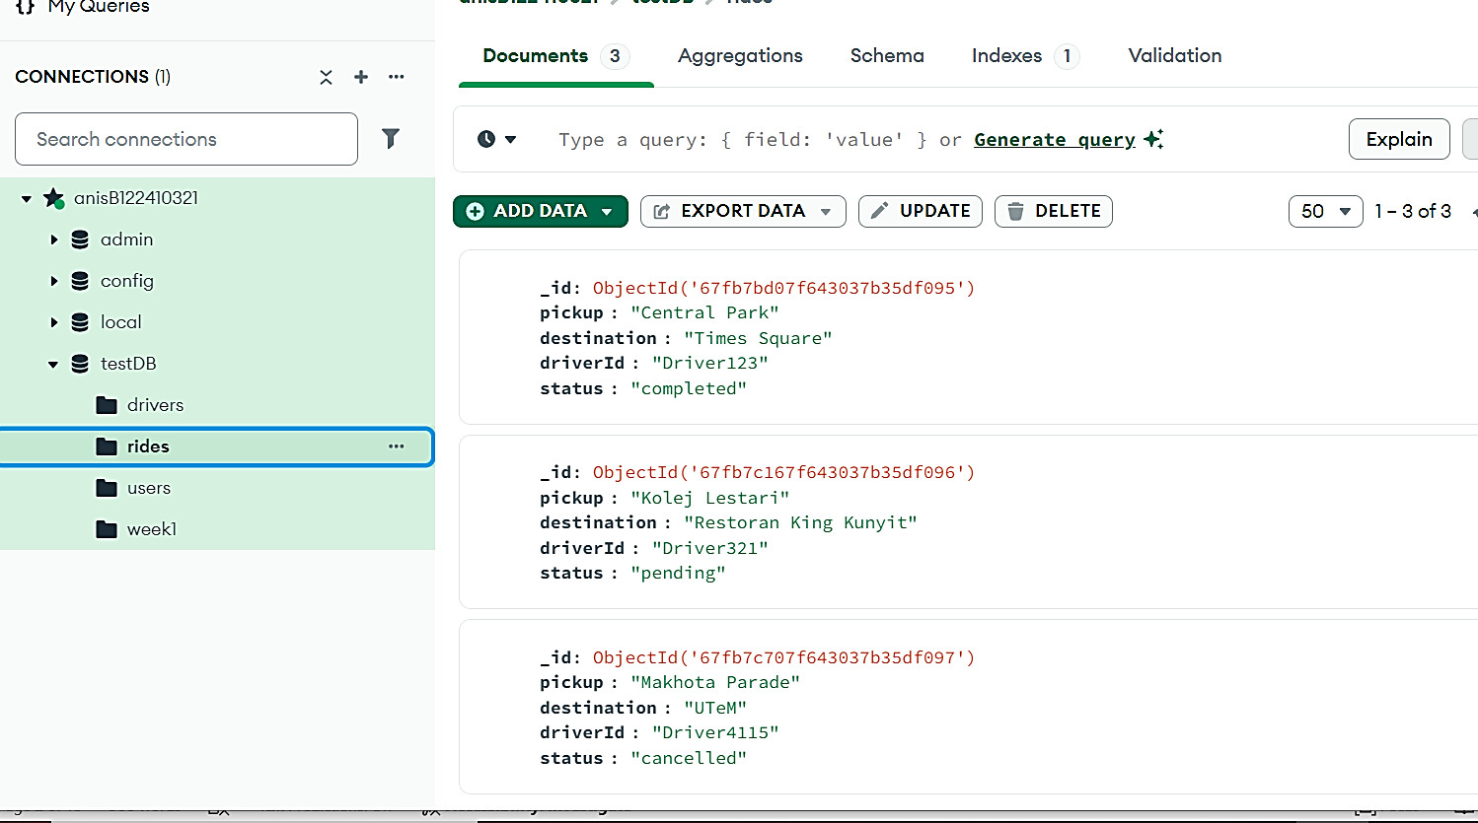

1. **Screenshots of:**

* **Postman requests/responses.**

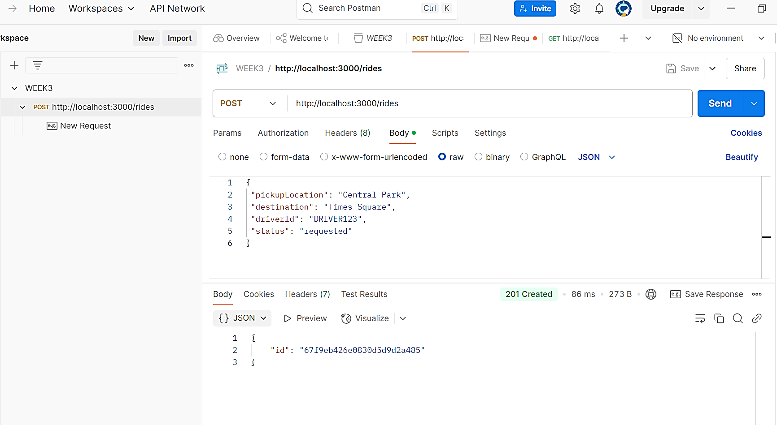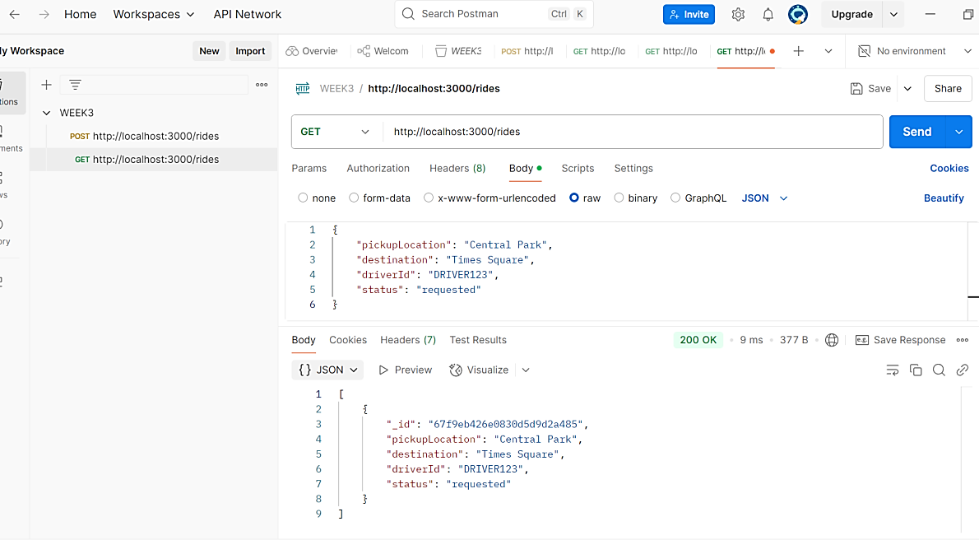

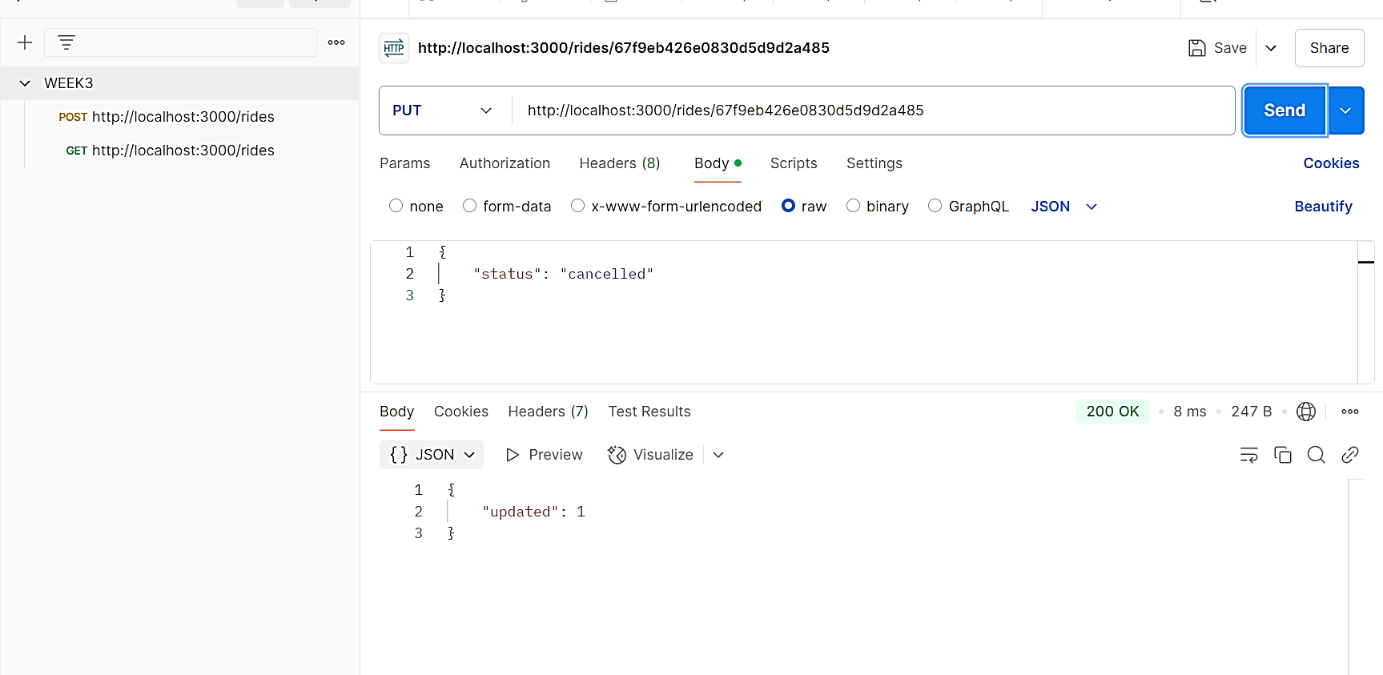 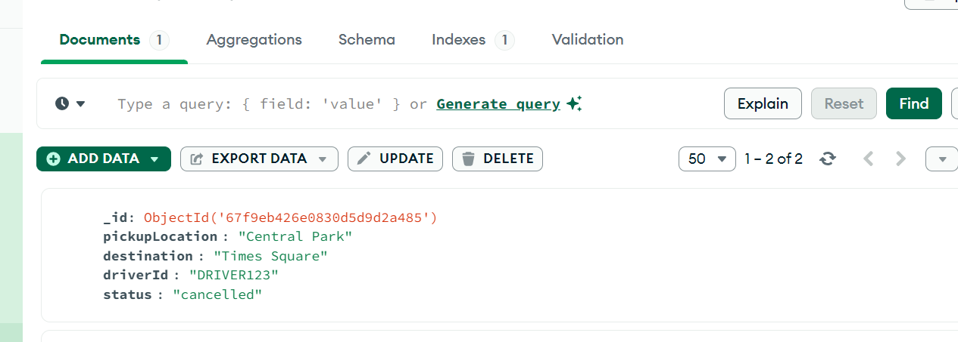

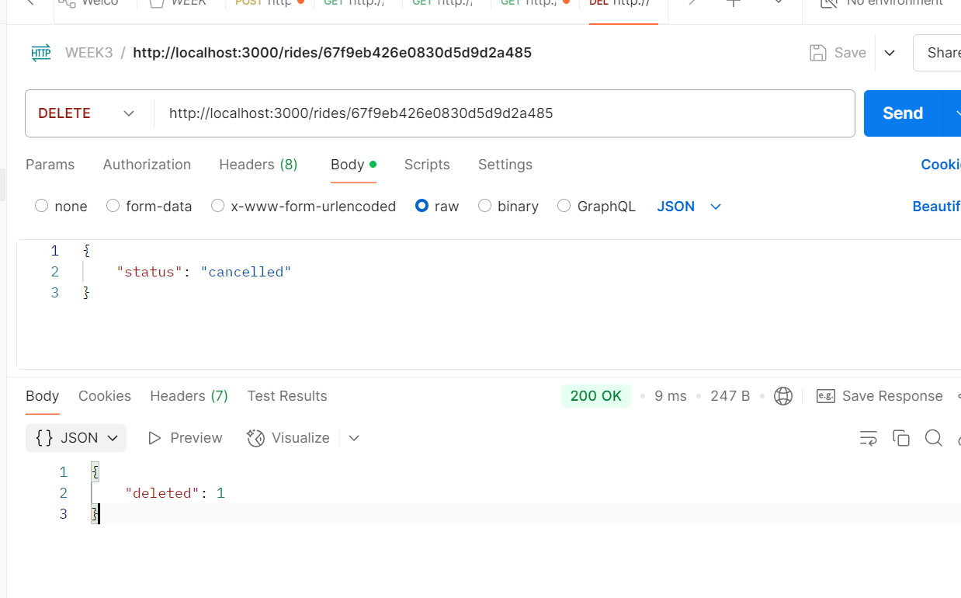

**Exercise Questions**

**Answer 1:**

* 201 created
* Response body :



**Answer 2:**

* Rides collection is empty : when a collection is empty. It's a standard way to indicate that the request was successful but there are no items

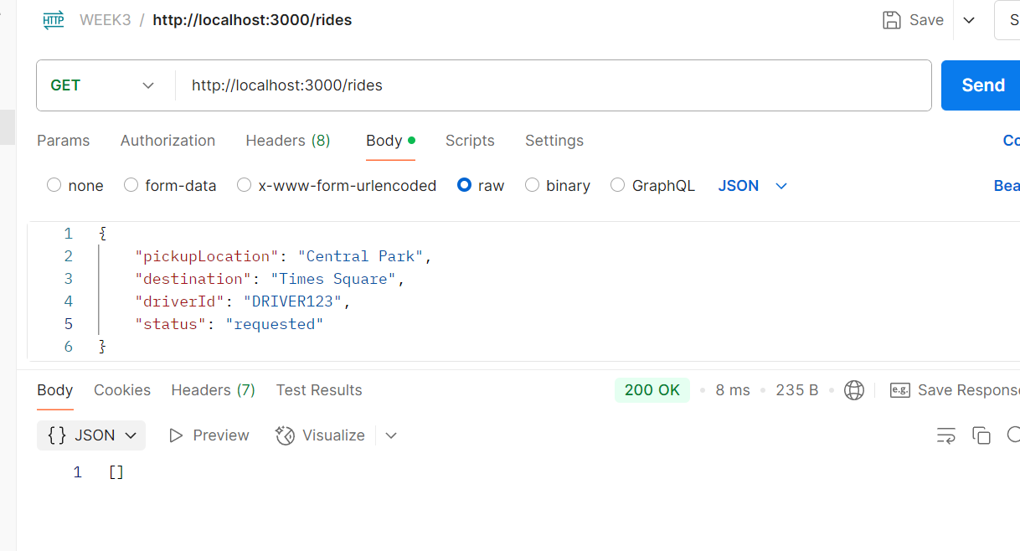

**Answer 3:**

* Catch the error when requesting PATCH :

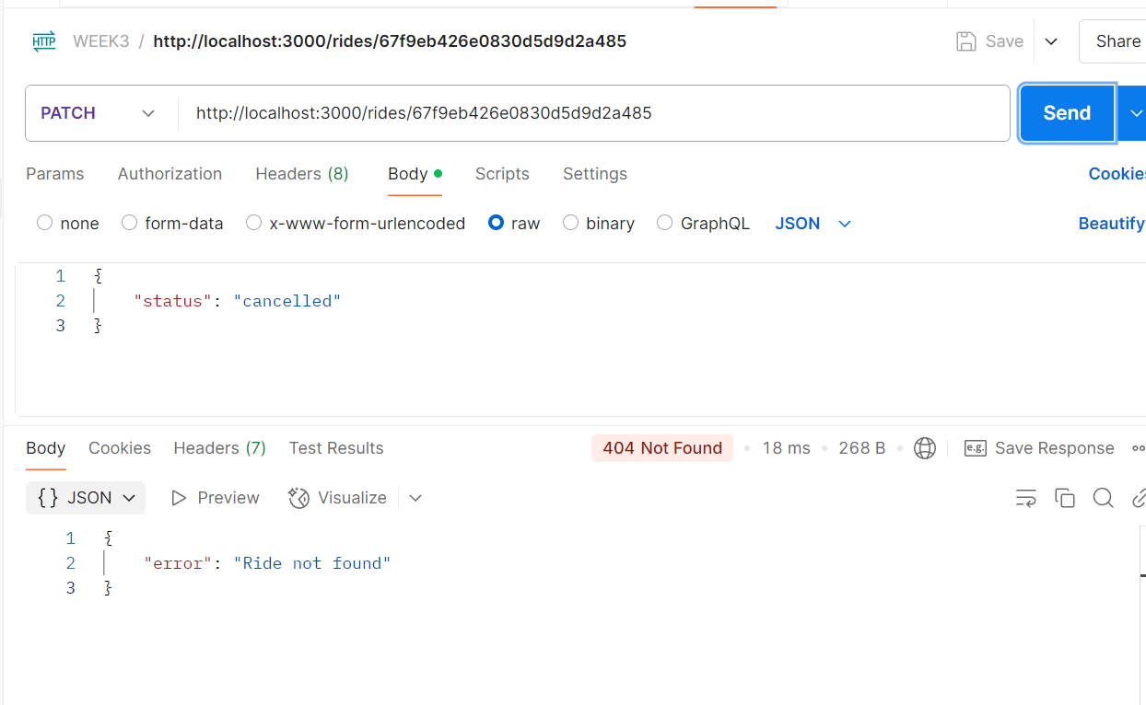

-To update a non-existent ride ID, the status code is returned : **404 Not Found**

- Value of updated in the response if the update succeeds :

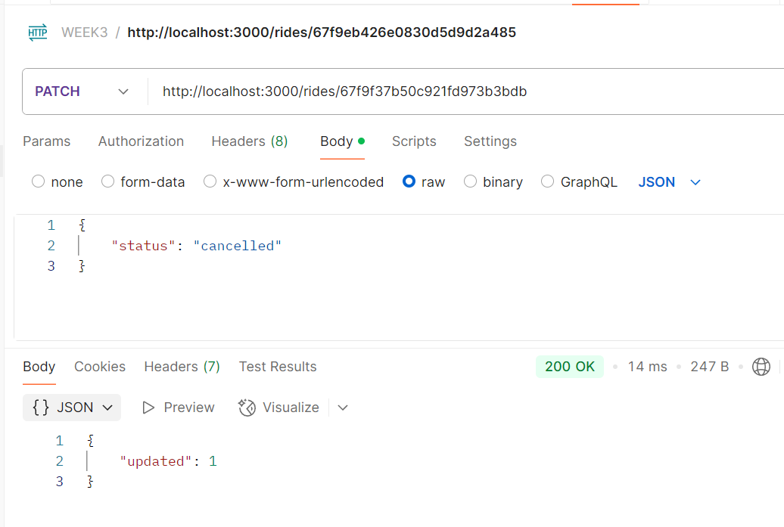

- API differentiates between a successful deletion and a failed one :

If deletedCount === 1 → Successful → 200 OK

If deletedCount === 0 → Not found → 404 Not Found

**Answer 4 :**

* Users Endpoints :

CRUD operations for users account

// GET /rides = Fetch all rides

app.get('/users', async (req, res) => {

try {

const rides = await db.collection('users').find().toArray();

res.status(200).json(users);

} catch (err) {

res.status(500).json({ error: "Failed to fetch user" });

}

});

// POST /rides - Create a new user

app.post('/users', async (req, res) => {

try {

const result = await db.collection('users').insertOne(req.body);

res.status(201).json({ id: result.insertedId })

} catch (err) {

res.status(400).json({ error: "Invalid user data" });

}

});

// PATCH/users/:id - Cancel a user status

app.patch('/users/:id', async (req, res) => {

try {

const result = await db.collection('users').updateOne(

{

_id: new ObjectId(req.params.id) },

{ $set: { status: req.body.status }}

);

if (result.modifiedCount === 0) {

return res.status(404).json({ error: "User not found"});

}

res.status(200).json({ updated: result.modifiedCount });

} catch (err) {

res.status(400).json({ error: "Invalid user ID or data" });

}

});

// DELETE /users/:id - Cancel a user

app.delete('/users/:id', async (req, res) => {

try {

const result = await db.collection('users').deleteOne(

{ _id: new ObjectId(req.params.id) }

);

if (result.deletedCount === 0) {

return res.status(404).json({ error: "User not found"});

}

res.status(200).json({ deleted: result.deletedCount});

} catch (err) {

res.status(400).json({ error: "Invalid user ID" });

}

});

**Answer 5 :**

-Upload the Postman JSON to any AI tools, and generate a simple HTML and JS Dashboard

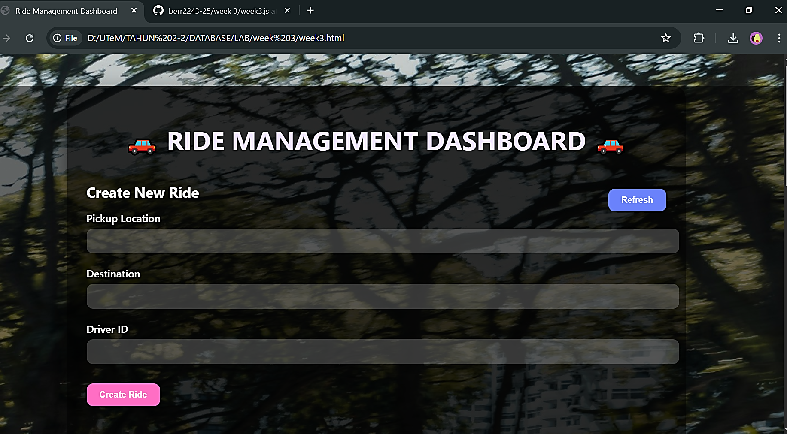

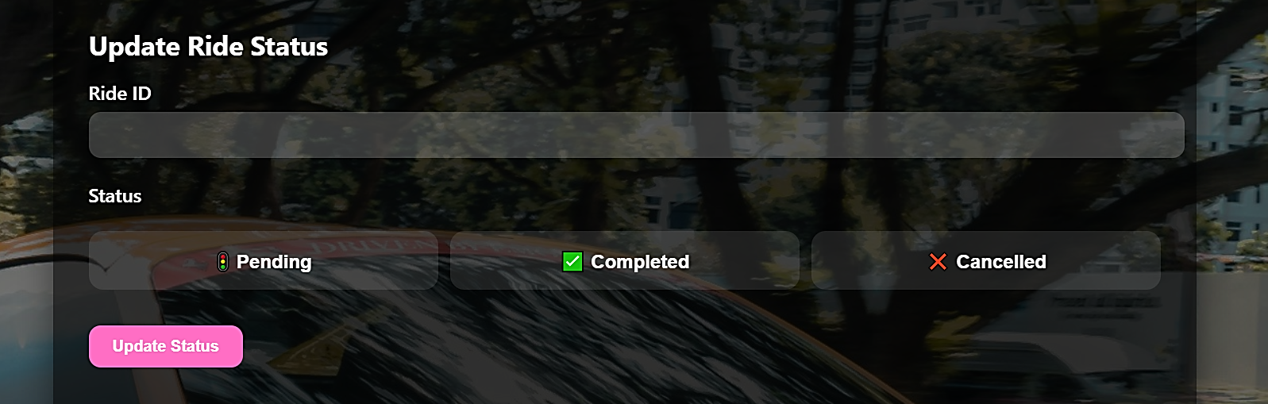

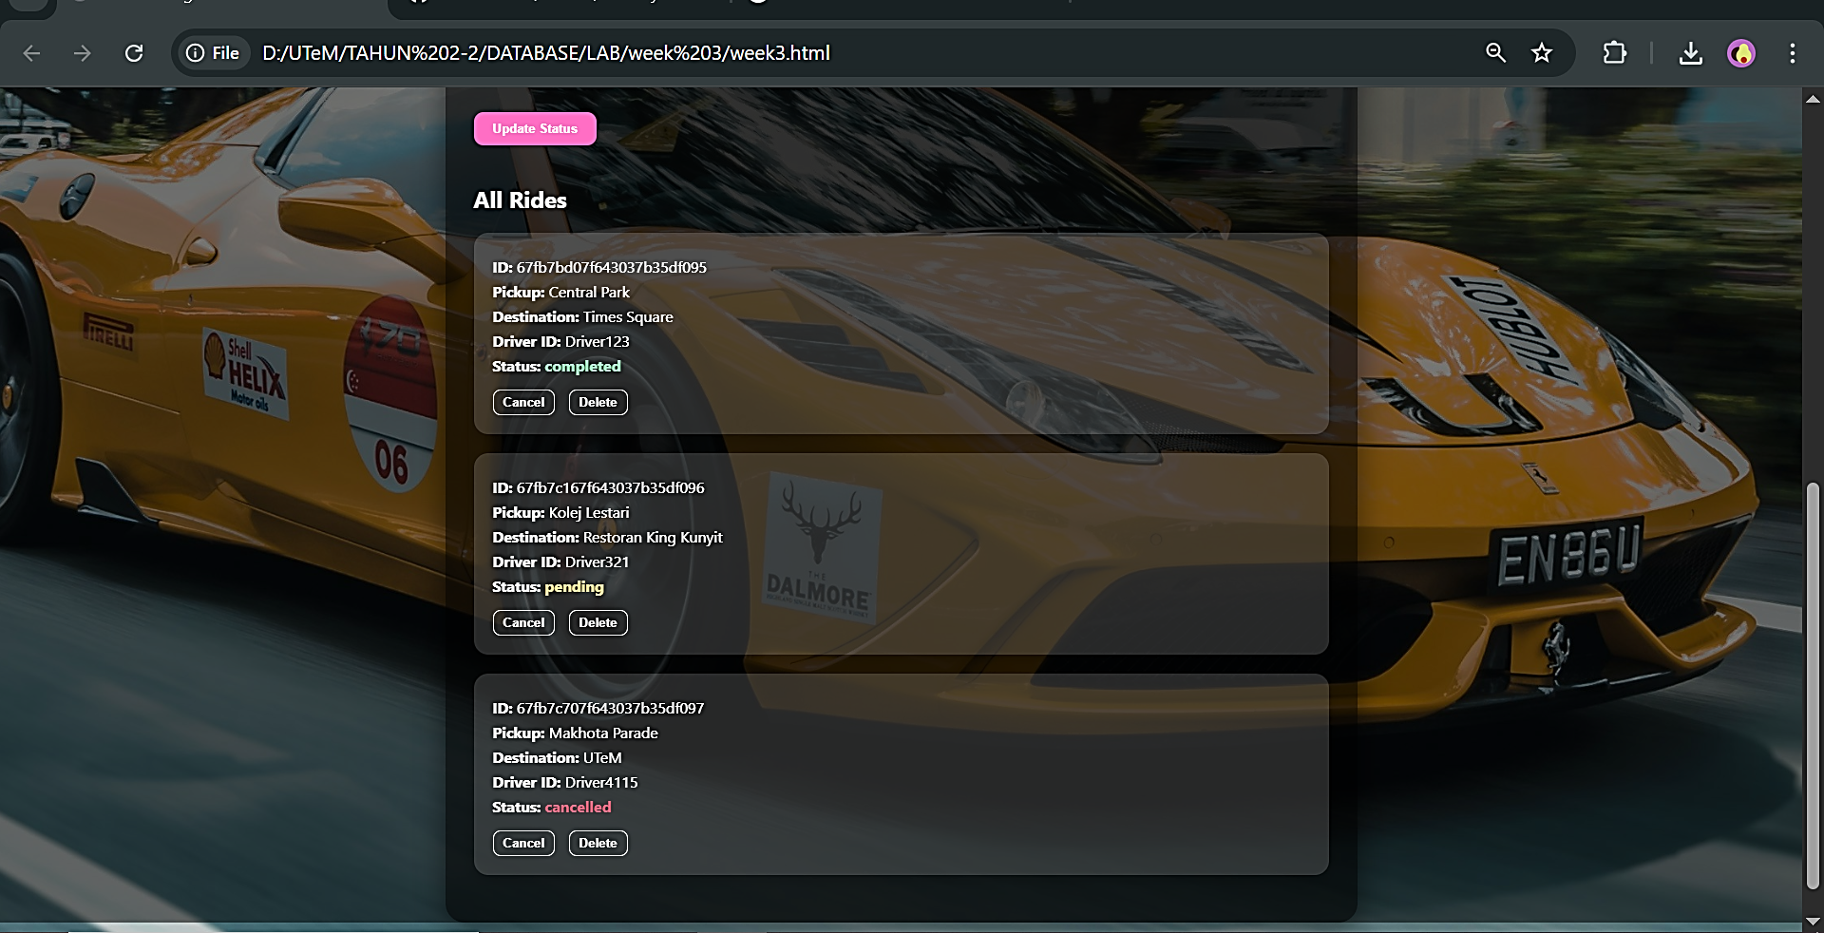

**Nur ain hidayah binti abdul rahim(b122410323)**  
Submission Requirements

1. GitHub Repository with:

o Complete code.

Github link: <https://github.com/b122410323/berr2243-25.git>

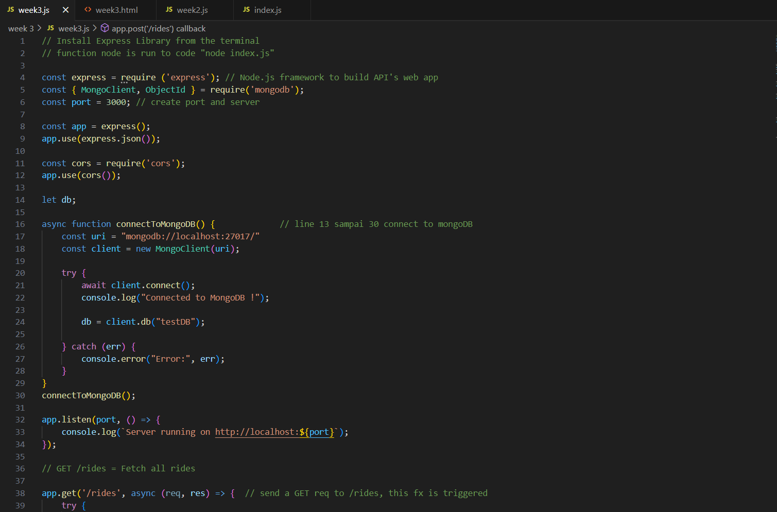

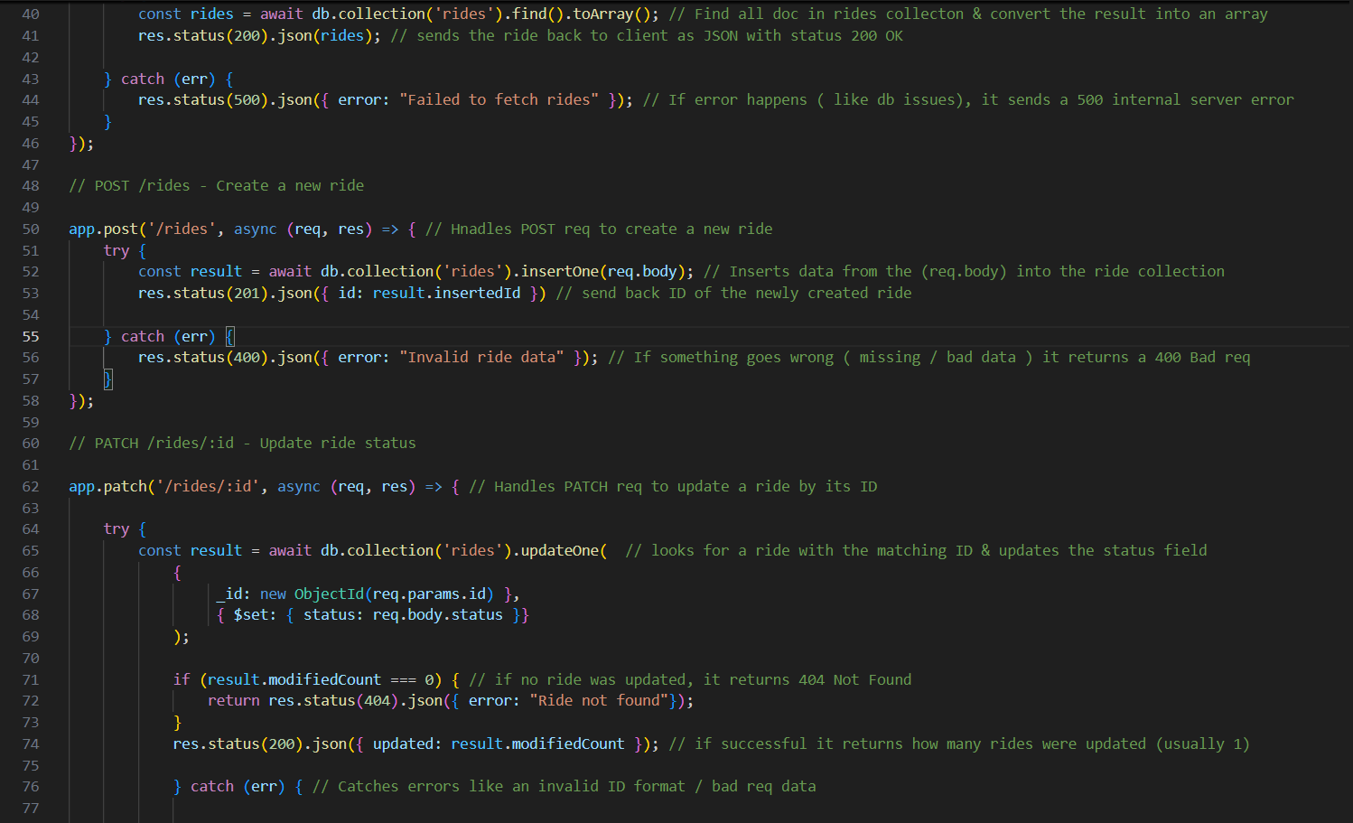

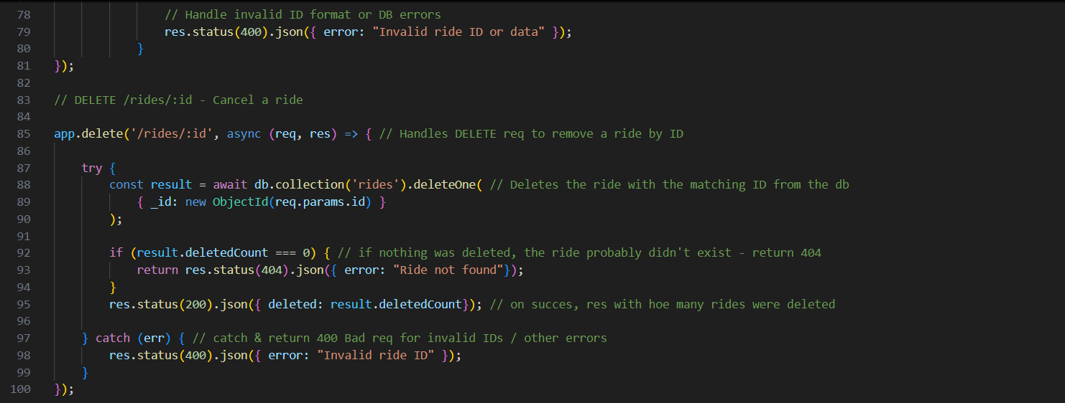

Github

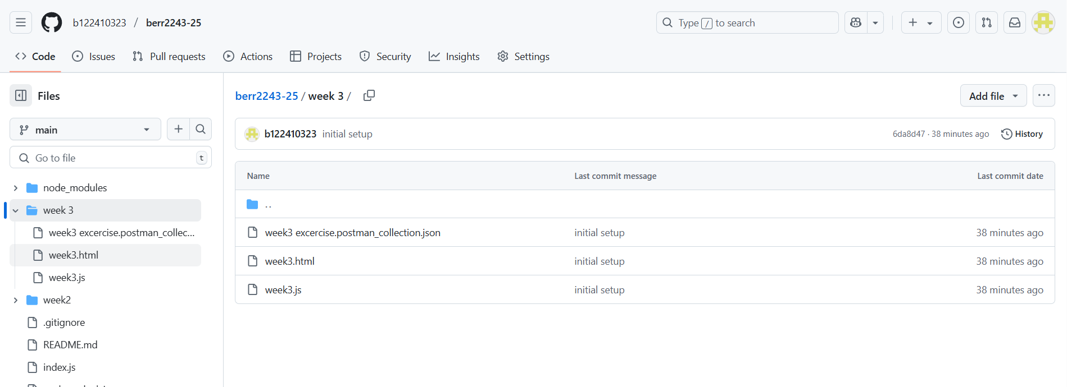

2. Postman Collection:

o Export and include the collection file.

3. Exercise Report:

o Screenshots of Postman requests/responses.

Answer:  
1. POST Request:

o What HTTP status code is returned when a ride is created successfully?

-201 created

o What is the structure of the response body?

-”id”: “67f9e66fd820fc6423d2f2f0”

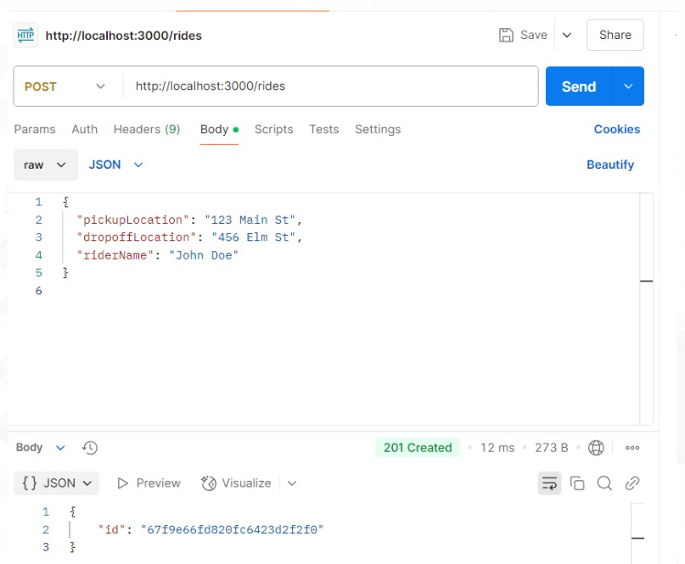

2. GET Request:

o What happens if the rides collection is empty?

o What data type is returned in the response (array/object)?

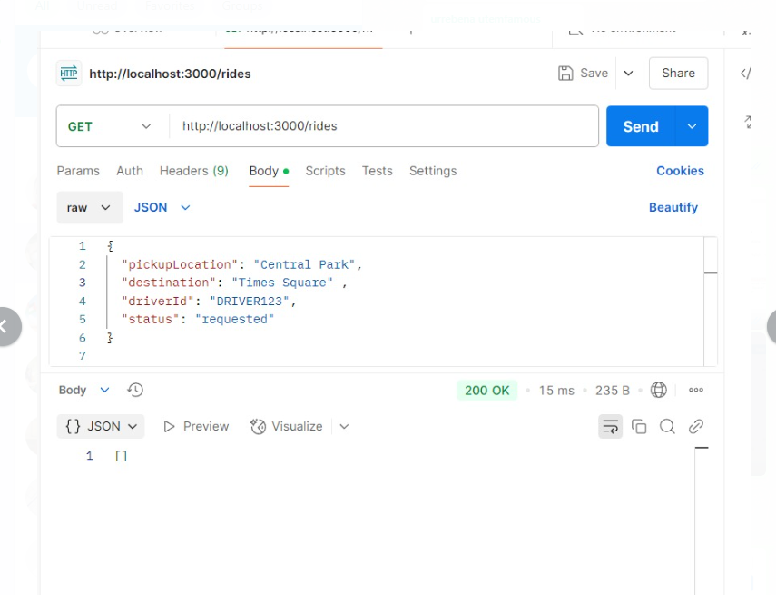

3. Fix PATCH and DELETE Error:

o Catch the error when requesting PATCH or DELETE API, then try to fix

the issue reported.

o If you try to update a non-existent ride ID, what status code is

returned?

-404 not found

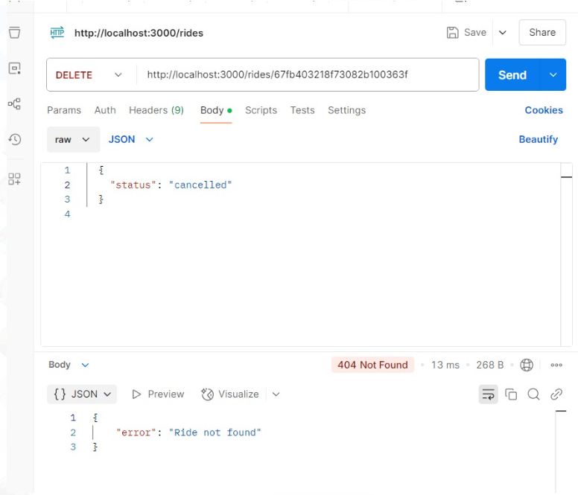

o What is the value of updated in the response if the update succeeds?

-if the output in postman exist "updated":1 that means update succes

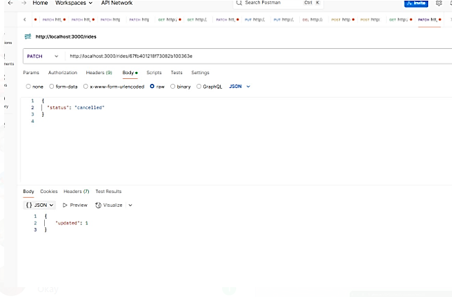

o How does the API differentiate between a successful deletion and a

failed one?

-succesful deleted will be like this

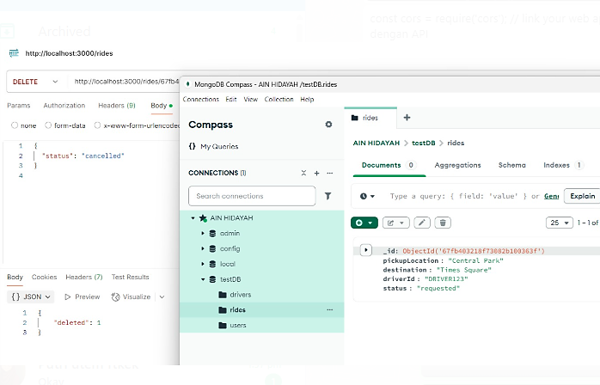

4. Users Endpoints:

o Based on the exercise above, create the endpoints to handle the CRUD

operations for users account

5. FrontEnd:

o Upload the Postman JSON to any AI tools, and generate a simple HTML

and JS Dashboard for you

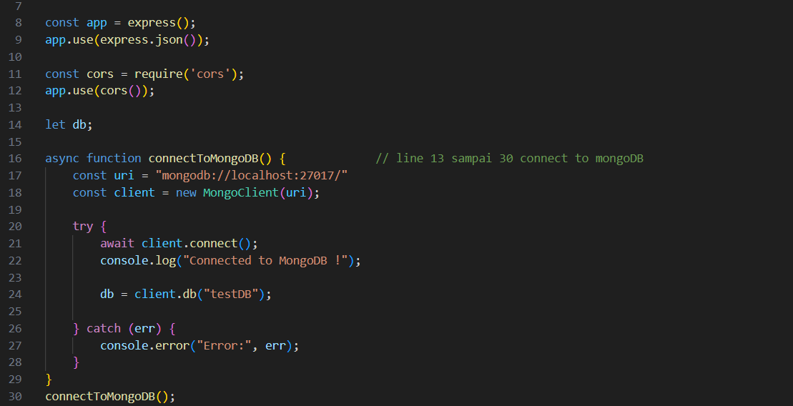

HTML Dashboard

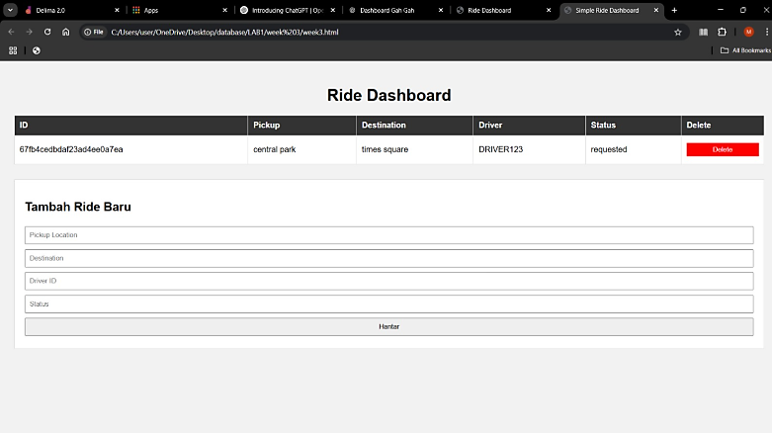

Output in mongoDB

